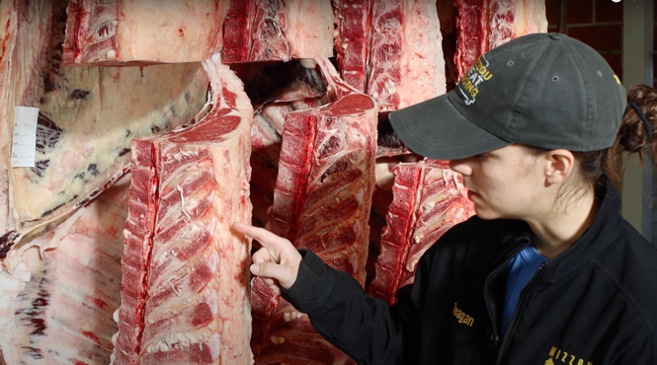

**MEAT SCIENCE: QUALITY AND YIELD GRADES WITH TEAGAN SCHNURBUSCH**

**Educational Objectives:**

* Compare the processes of yield and quality grading on beef carcasses.
* Calculate the yield and quality grade of a beef carcass based upon USDA guidelines.
* Summarize the importance of quality and yield grading.

**Teacher Instructions:**

* Locate the “Meat Science: Quality and Yield Grades with Teagan Schnurbusch” video by visiting: [cafnr.missouri.edu/ag-science-videos/](https://cafnr.missouri.edu/ag-science-videos/). Instruct students to fill in the blanks on the next two pages while watching the video. After the video completes, students can reflect on and answer the remaining questions found on the last page.

**Additional Instructional Opportunities:**

* Allow students time to research “careers in meat sciences” and choose one that interests them most. Students can write a blog that highlights key information about this career.
* Invite a local meat processor or other meat science expert to class to discuss the topic of yield and quality grading with students.
* Obtain a set of USDA Marbling Cards and USDA Beef Ribeye Grids. Print out pictures of beef carcasses and ribeye muscles for students to practice quality and yield grading. The hot carcass weight and KPH will need to be provided to the students.
* Instruct students to visit the University of Missouri CAFNR [Animal Sciences Team webpage](https://animalsciences.missouri.edu/animal-sciences-teams/). Provide time for students to read information about the Meat Judging Team and host a class discussion about what a competing on the University of Missouri Meat Judging Team could look like.

*Teagan Schnurbusch, Meat Science PhD student, quality and yield grades beef carcasses at the University of Missouri.*

**CAFNR Career Exploration Video Series**

**QUALITY vs. YIELD GRADING:**

1. Quality grading is the __________________ score, or intramuscular fat. An increased amount of marbling leads to flavor, tenderness, juiciness, and palatability.
2. Yield grading is how much __________________ the product is going to get. Yield grading consists of four factors: hot carcass weight, backfat, ribeye size, and KPH fat.

**YIELD GRADING FACTORS:**

1. Hot Carcass Weight: The hot carcass weight is the weight of the carcass after the ___________ and ________________________ have been removed. What was the hot carcass weight for the carcass in the video? ______ lbs
2. KPH: KPH stands for __________, __________, and __________ fat. What was the KPH percentage for the carcass in the video? ______%
3. Ribeye Size: The ribeye size is measured using the grid. On the grid, 10 dots equals _______ square inch(es). How large was the ribeye in the video? ______ sq. in.
4. Backfat (PYG): The backfat is measured by starting at the backbone and going 3/4 around the ribeye. The end of the probe should be touching the ________________________. What was the PYG for the carcass in the video? ______

**FINAL YIELD GRADE:**

1. The Yield Grade Calculation formula is:

(PYG) +/- (REA Adj.) +/- (KPH Adj.)

What was the final yield grade for the carcass in the video? ______

**QUALITY GRADING FACTORS:**

1. Marbling: Marbling is measured by looking at the amount of marbling present in the ___________. What was the marbling score for the ribeye in the video? ___________
2. Age of Carcass (Maturity): The age of the carcass is measured by looking at the thoracic buttons and how much ________ _____________ has occurred. When we see cartilage, we know it is a _________ animal. What was the maturity score of the carcass in the video? ______

**FINAL QUALITY GRADE:**

1. The quality grade chart takes into account the two quality grading factors. What was the final quality grade for the carcass in the video? ______

***After watching the video, reflect on how quality and yield grading impacts the food industry by answering the following questions:***

* Why do meat processing plants use quality and yield grades?
* What is marbling and how does it impact the eating experience of beef products?
* Prime and choice are two quality grades that you may see on restaurant menus or on meat advertisements. What is the difference between prime and choice steaks?
* Let’s pretend that you work at a USDA inspected meat processing plant and your job is to assign yield grades. In your own words, describe the purpose of the four factors that are used to calculate a yield grade.
* Summarize the importance of using USDA quality and yield grades in the beef processing industry.